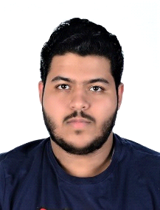**Ali Hussain Ali Altaweel**

Male, Bahraini 22 years old

Jidhafs, building 2034, road 2553, block 425

Email:

alihussainaltaweel@gmail.com

Contact: 36222594

**PERSONAL INFORMATION**

CPR:971203911

Father name: Hussain Ali Altaweel

Date of Birth:11/12/1997

Marital status: single

Languages known: Arabic and English

**EDUCATION**

**9/2012 – 9/2015 general certificate of secondary school****-alghad tranning institute**

**3/2016 – 9/2016 ismm level 4 certificate in sales and marketing management-ALGHAD TRANNING INSTITUTE**

**3/2017 – 10/2017 ismm level 4 diploma in sales and marketing managment-ALGHAD TRANNING INSTITUTE**

**2/2018 – 9/2018 ISMM Level 5 Diploma In Sales And Account Management-ALGHAD TRANNING INSTITUTE**

**skills&abillities**

-Ability to work in a fast-paced.

-Polite, respectful, regular and manners.

-Work well under pressure as part of a team.

**software skills**

-Operating system: windows XP, 7 and 10

-packages: MS Office (Word 2003-2016, PowerPoint2003-2016)

**hobbies**

-reading business books

-Traveling

**references**

References available upon request